About
Mock Red Lobster Restaurant reservation system: includes website UI, Java backend, submissions fed to MySQL database. A CRUD demo is shown below.

CREATE
Dallas Cowboys quarterback Dak Prescott will be our guest today!
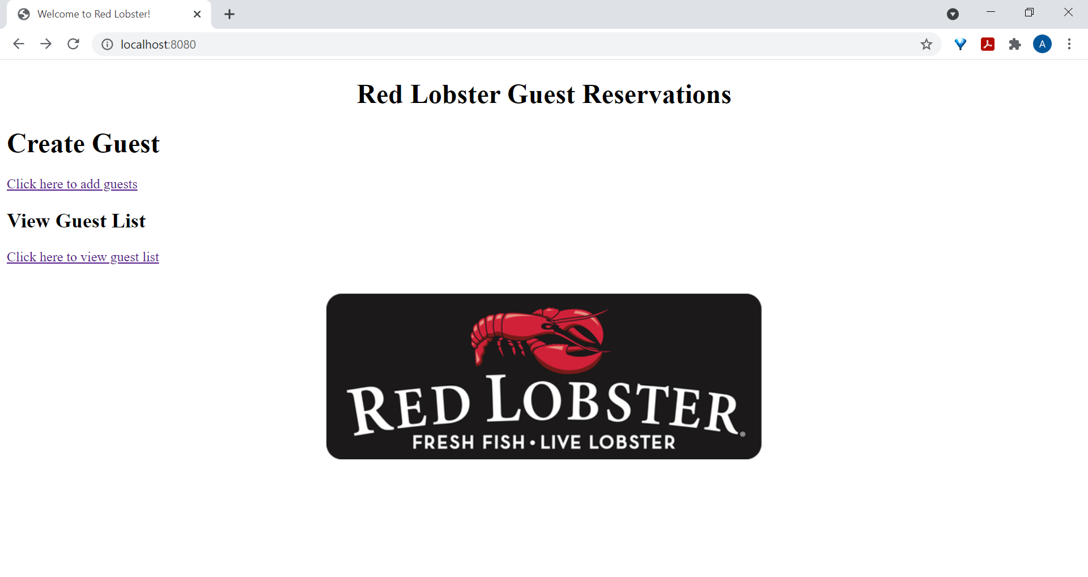

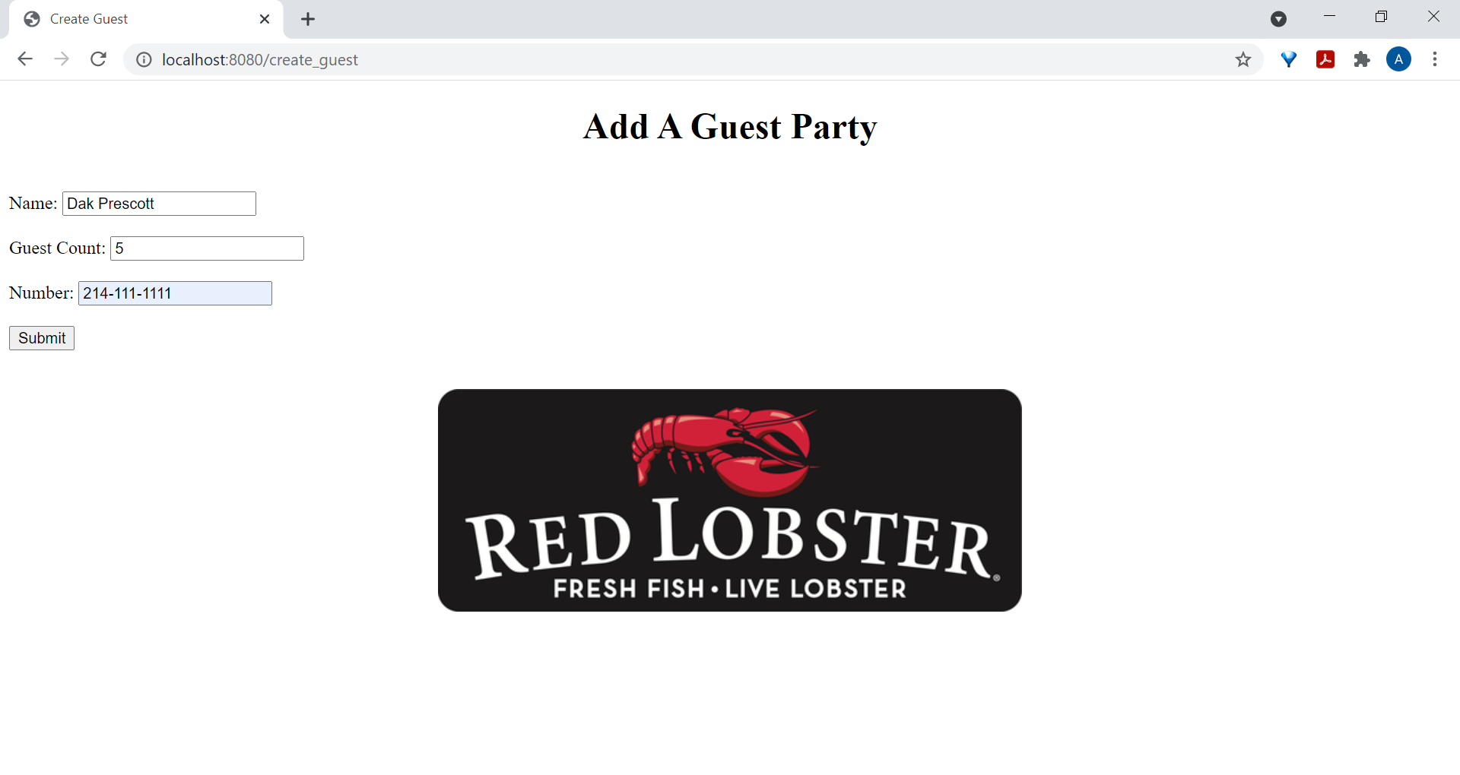

READ
Great! Former Dallas Mavericks basketball player Dirk Nowitzki is also on the guest list.
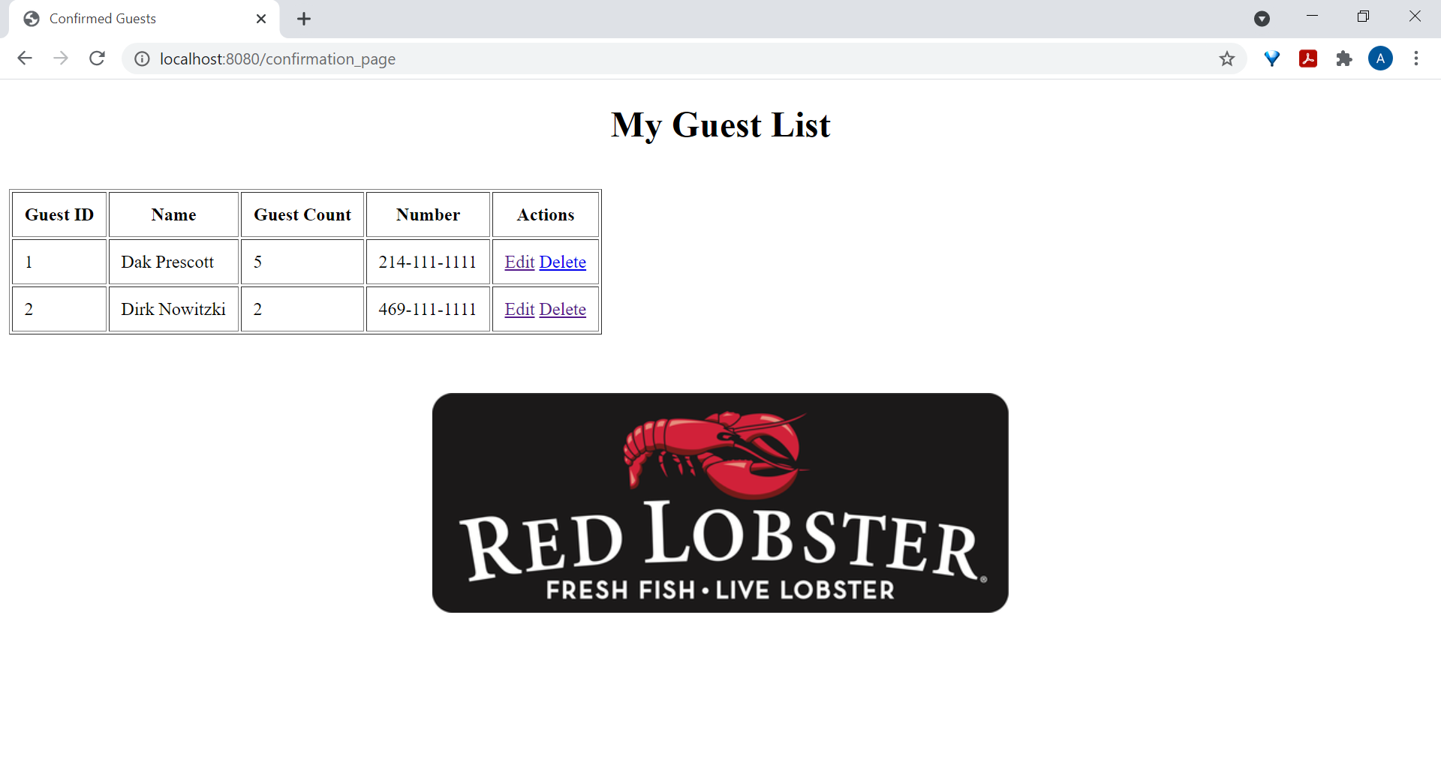
UPDATE
Looks like Mr. Prescott will be bringing Dallas Cowboys owner Jerry Jones too!
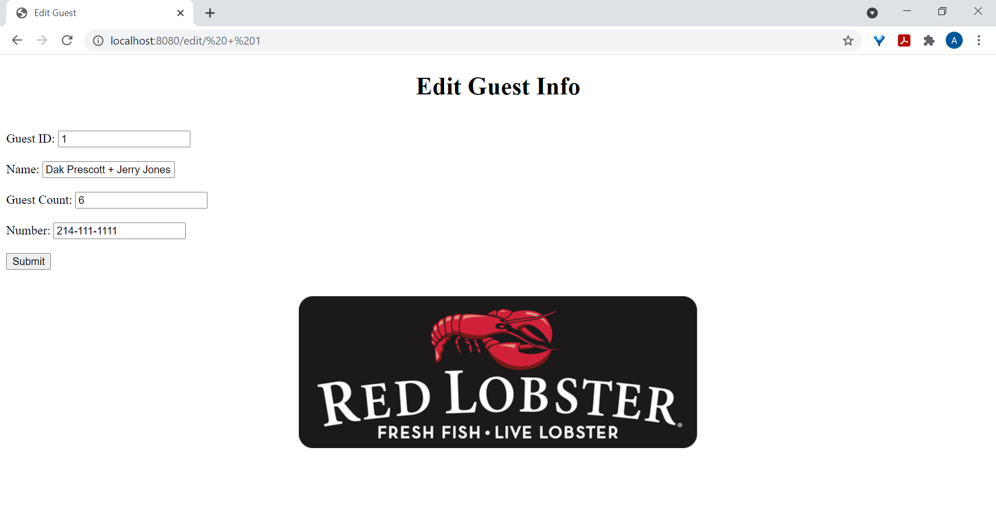
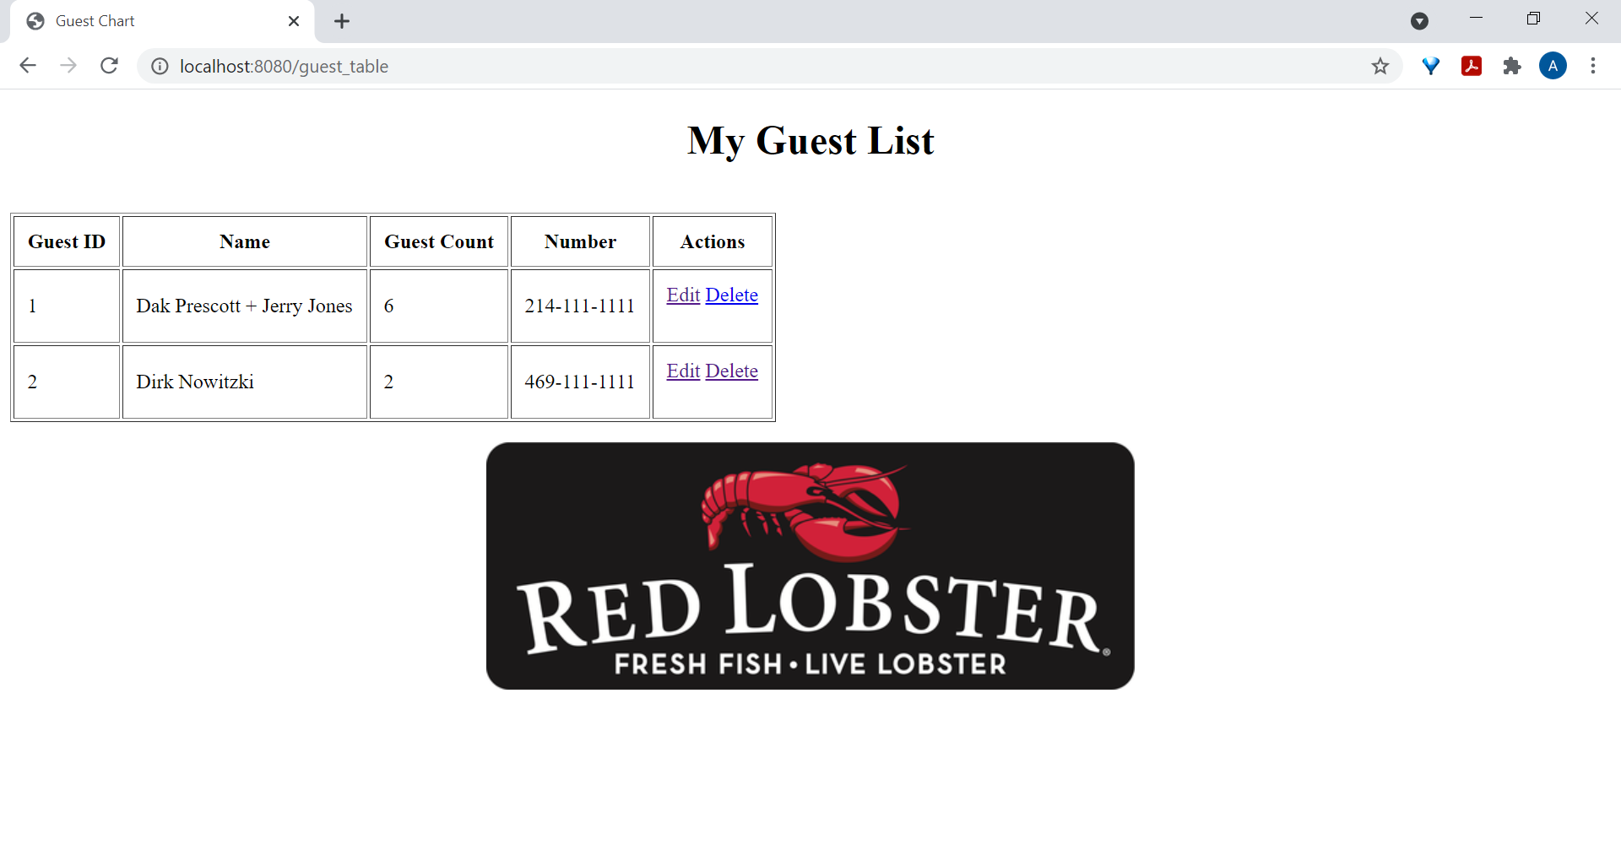
DELETE
Darn! Dirk Nowitzki will no longer be joining our restaurant this evening.

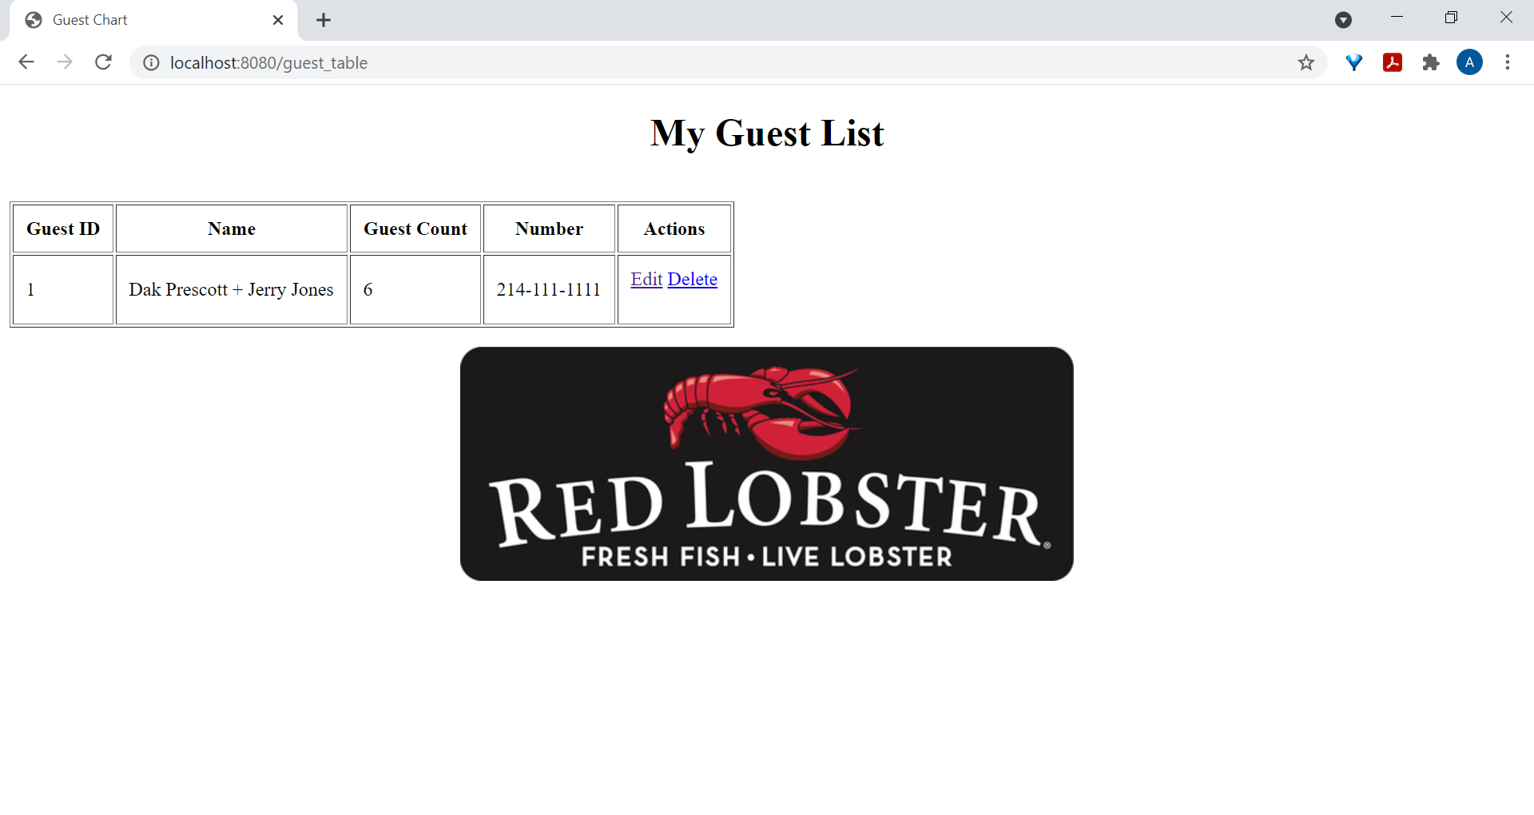

Backend
